When doing a zoom there are some settings that can be applied ahead of time. If you are scheduling a zoom with cohosts, or zooms that are to be done in Hock 214 or Hock 10089, please follow the instructions below to apply some necessary settings ahead of time.

Please proceed to [duke.zoom.us](https://duke.zoom.us/) and sign-in. Then choose “Settings” on the panel to the left.



It is the 11th option

Across the top of settings are different pages with options. We will begin with “Meeting”, the 3rd option.

As we scroll down we will see a subheading labeled “Schedule Meeting” Under that meeting we have

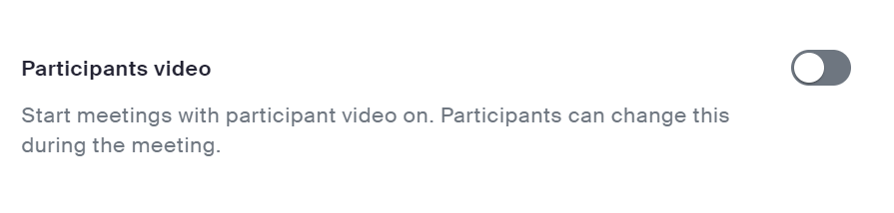

“Participants video” Please turn this option off. Allow participants to turn on the camera when they are set up and ready

In the same section, underneath the watermark screen examples please, please, please, please select “Mute all participants when they join a meeting”

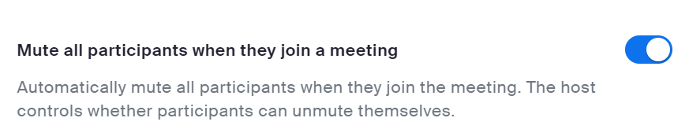

Mute on entry. Prevents accidental conversations.

Keep scrolling to the section “In Meeting (Basic)”

Allow the Co-Host to have host contols

Just in case

A little bit further down you will see “Who can share?” The classroom itself is different from the account of the AV person. All participants will need to be able to share in order for the classroom to be able to share the speaker’s content to the Zoom, as well as in the room.



That should be all of the settings we need to change on the website. Other settings can be modified on the zoom desktop application.

**Recording**

If you are recording the meeting, you should choose that setting when you schedule the meeting (on the zoom workplace desktop application.) At the bottom of the schedule meeting information choose “Advanced Options”

This will open a section with several options. Please choose and then “In the cloud”

“Automatically record meeting” & “In the cloud”

If this is a meeting for a classroom please allow [mef68@duke.edu](mailto:mef68@duke.edu) and/or James Thomas (thoma093@duke.edu) to be alternate hosts.

Cloud recordings can be found online at [duke.zoom.us](https://duke.zoom.us/) -> Recordings

If you cannot find a recording, please search the trash folder as well. Zoom seems to be automatically sending files there these days.